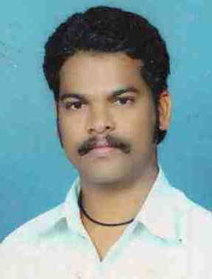
V Sharanappa
V Sharanappa Koni
Devaraj Urs Colony,
Behind Ilahi Masjeed, Koppal
Koppal - 583231
Telephone: 9538321506
e-mail: vijay_sharanu1566@yahoo.in

CAREER OBJECTIVE

To work in a challenging and position with growth oriented environment and be known for depth of knowledge, innovative ideas, hard work, quality, timeliness of service and honoring the commitments.

WORK EXPERIENCE

Taluk Panchayat, Koppal Nov, 2008 – March, 2012

Taluka MIS Co-Ordinator/Executive,

Major Responsibilities:
- Computing all Official Works
- Working with NREGA Web Based Software
- Maintaining Accounts Section
- HRMS Web Based Software
- Managing and training Taluka all GP's Operators,
- MNREGA Section Management with Correspondences along.
- More Others.

Dr. B.R Ambedkar Development, Corp., Koppal Feb, 2002 – August, 2008

System Analyst cum Computer Operator,

Major Responsibilities:
- Computing all Official Works
- Maintaining DCB Software
- Posting the receipts using DCB
- Computing Accounts using Tally
- Others

Venus Computer Center, Koppal June, 2001 – Jan, 2002

Honorarium Hardware Engineer.

Major Responsibilities:
- Installation and servicing the computers
- Trouble shooting

Experience in total 11 Years

EDUCATION
Sri Gavisiddeshwara Degree College, Koppal

BA April, 2004

APTECH Computer Education, Koppal

DCS (Diploma in Computer System) March, 2005

Jetking - Rajajinagar
(JCHNP–Jetking Certified Hardware & Networking Professional)-15 months career course

Continues …

Page – 2, Cell : 9538321506 V Sharanappa Koni

FUNCTIONAL SKILLS
- Good experience with MS Office
- Basics of MATLAB
- Well knowledge with Internet
- Man Power Management Skills
- Good Type writing skill

INTERESTS/ACTIVITIES
- Reading
- Watching TV

PERSONAL DATA

Date of Birth : 23rd June, 1983
Age : 30
Languages known : English, Kannada, Hindi
Nationality : Indian
Present Address : V Sharanappa Koni
1st 'C' main, Shivanagar,
Rajajinagar, Bangalore -10

Contact : +91 9538321506
9742657543

Preferred Job Location
- Bangalore

Sd/-
(V Sharanappa Koni)

